Excel Assignment - 7

- Using Insert Function, give examples of any function available in the different dropdowns present in the function library. For example AutoSum, Recently Used, Text, Date & Time, etc.
Ans:
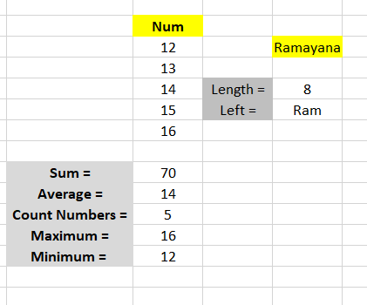
And so on….

2. What are the different ways you can select columns and rows?
Ans: Select one or more rows and columns or click on any cell in the column and then press Ctrl + Space. Select the row number to select the entire row. Or click on any cell in the row and then press Shift + Space.

3. What is AutoFit and why do we use it?
Ans: AutoFit is a feature in Excel that lets you easily change the size of one or multiple columns or rows on a spreadsheet. It helps you make sure that all the data in every cell group is clearly visible.

4. How can you insert new rows and columns into the existing table?
Ans: To add a row above the cell, click Insert Above in the Rows and Columns group. To add a row below the cell, click Insert Below in the Rows and Columns group.

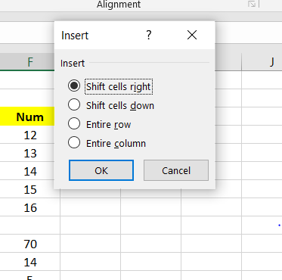

5. How do you hide and unhide columns in excel?
Ans: Use the shortcut Ctrl + 9 to hide rows and Ctrl + 0 to hide columns. Click the Home tab and in the Cells group, click Format > Hide and Unhide and pick either Hide Rows or Hide Columns.

6. Create an appropriate table within the worksheet and use different functions available in the AutoSum command.
Ans:
